Bash Scripting assignment02

Conditions/ifelse statements:
============================

If then statement
If this happens =do this
otherwise =do that

Ex:
#!/bin/bash
count=100
if [ $count -eq 100 ]
then
echo count is 100
else
echo count is not 100
fi
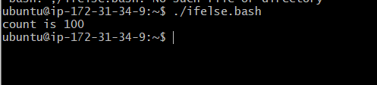

Ex2:
check if file is available
#!/bin/bash
if [ -e /home/error.txt]
then
echo "File exist"
else
echo "File does not exist"
fi
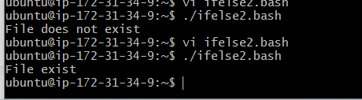

Case Statement Scripts:
======================
This will be used when we have multiple options to script

Case

if option a is selected = do this
if option b is selected = do this

Ex:

#!/bin/bash

echo
echo Please chose one of the options below
echo
echo 'a = Display Date and Time'
echo 'b = List file and directories'
echo 'c = List users logged in'
echo 'd = Check System uptime'
echo

read choices

case $choices in

a) date;;
b) ls;;
c) who;;
d) uptime;;
*) echo Invalid choice - Bye.
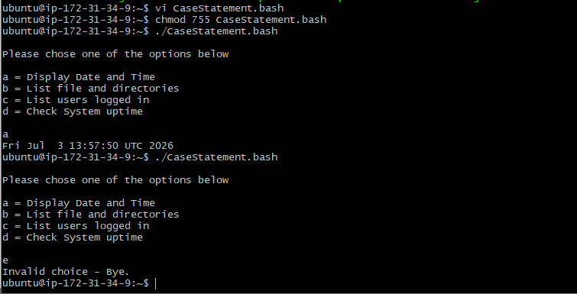

For Loop Scripts:
================

For loop keeps running until specified number of variable.
e.g: variable = 10 then script run for 10 times.

or

varible = green,blue,red (then run the script 3 times for each color)

Ex:1

#!/bin/bash

for i in 1 2 3 4 5
do
echo "Welcome $i times"
done

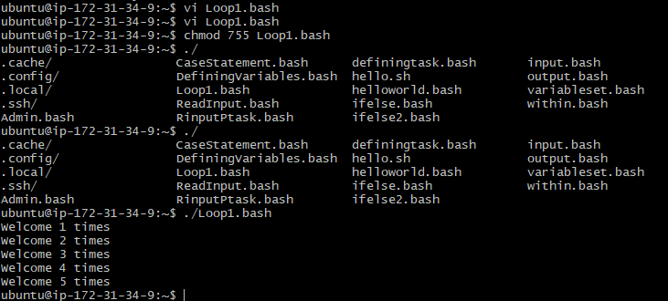

Ex:2
for i in eat run jump play
do
echo See Venu $i
done

Do-while Scripts:
================
This will continually executed a block of statements while a particular condition is true or met.

e.g: Run a script until 2 pm

while [ condition ]
do
command 1
command 2
commandN
done

Ex1:

#!/bin/bash

count=0
num=10
while [ $count -lt 10 ]
do
echo
echo $num seconds left to stop this process $1
echo
sleep 1

num=`expr $num - 1`
count=`expr $count + 1`
done
echo
echo $1 process is stopped!!!
echo
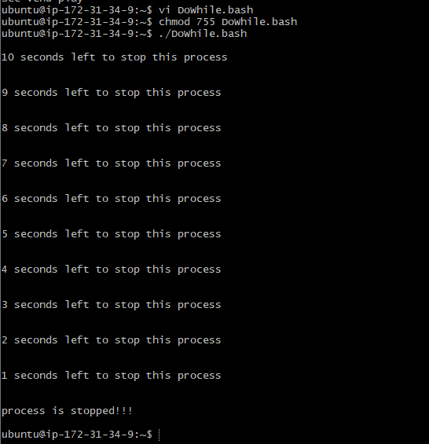

Exit status:
===========
Everytime a command is execute in linux it will have status is associated with it.

*) 0 = ok or successful
*) 1 = Minor problem
*) 2 = serious problem
*) 3-255 = Everything else

Why do we need exit status?
We actually do lot of comparisions in scripting and if the command is successful then do that or else do that.

How to check the exit status of previous execute command?
exit $?

Ex1:
#!/bin/bash

echo hello
echo $?
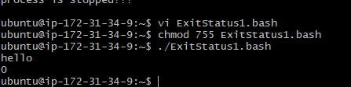

Ex2:
Return Un-Successful Exist Status

#!/bin/bash

echi hello
echo $?
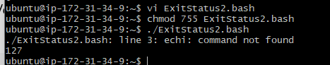
Ex3:
Return exist status if file exist

#!/bin/bash

ls -l /home/sabair/check

if [ $? -eq 0 ]
then
echo File exist
else
echo File does not exist
fi
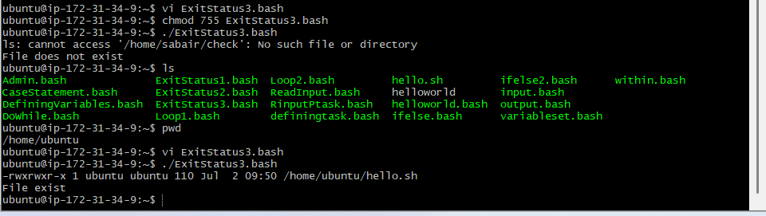

Cornjobs:
========
Cronjobs is used to run script without any manual intervention.

Example 1: Print "Hello VENU" Every Minute
Step 1: Create a Script
nano cornjob.bash
Step 2: Add the Script
#!/bin/bash
echo "Hello VENU - $(date)" >> /tmp/cornjob.log
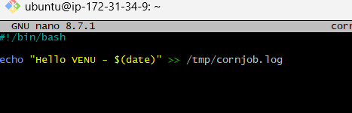
Step 3: Save the File
Ctrl + O
Enter
Ctrl + X
Step 4: Give Execute Permission
chmod +x hello.sh
Step 5: Open Cron Table
crontab -e
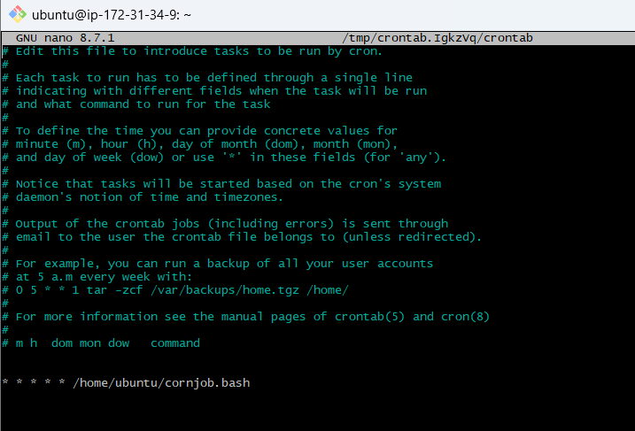
Step 6: Add Cron Entry
* * * * * /home/ubuntu/cornjob.bash
Replace /home/ubuntu/cornjob.bash with your script's full path.
Step 7: Verify
After one minute:
cat /tmp/cornjob.log
Output


Example 2: Take a Backup Every Day at 2:00 AM
Step 1
nano backup.sh
Step 2
#!/bin/bash
cp -r /home/ubuntu/Documents /home/ubuntu/Backup
echo "Backup completed on $(date)" >> /tmp/backup.log
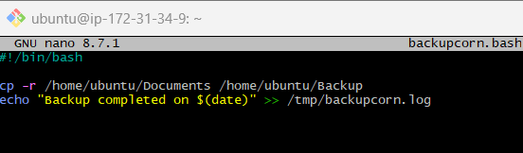
Step 3
chmod +x backup.sh
Step 4
crontab -e
Step 5
0 2 * * * /home/ubuntu/backup.sh Note: Backup will take everyday at 2am
